# Gas Sensor

A gas sensor (or gas detector) detects the presence and concentration of gases in the air. MQ-series sensors (e.g., MQ-2, MQ-3, MQ-7) are popular for detecting gases like methane, propane, alcohol, carbon monoxide, and more.

**Working Principle:**  
The sensor consists of a heating element and a sensor electrode. When gases are present, they react with the sensor surface, causing a change in resistance, which is then converted into a readable signal.

**Types:**  
- MQ-2: LPG, smoke  
- MQ-3: Alcohol  
- MQ-7: Carbon Monoxide  
- MQ-135: Air quality

**Applications:**  
- Gas leak detection  
- Indoor air quality monitoring  
- Breath analyzers  
- Safety and industrial control

**Advantages**:  
- Sensitive to a wide range of gases  
- Cost-effective  
- Easy to use with Arduino and Raspberry Pi

**Disadvantages**:  
- Needs calibration for accuracy  
- Preheating time required  
- May give false positives due to humidity or temperature

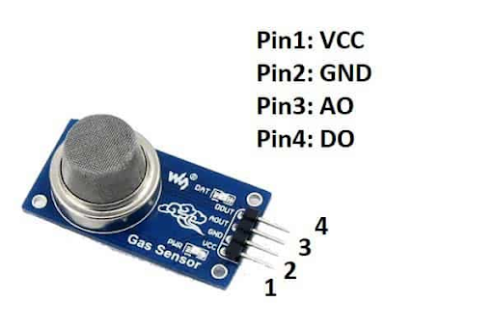

Fig: MQ2 Gas Sensor Module

**Pin Diagram:**

**VCC:** This pin is used for a positive voltage supply connection of 5V to power up the module.

**GND (Ground):** The module is connected to the ground using this pin.

**Digital Out (DO):** This pin is used to generate the digital output of the module when the threshold value is set with the help of a potentiometer. It gives the digital output either High Or Low based on the presence of gas.

**Analog Out(AO):** This pin gives the analog output voltage in the range of 0V to 5V, which depends on the gas intensity.